Public Transport Accessibility Analysis of Riga

1. Introduction
Geographic Information Systems (GIS) are widely used for transportation planning and accessibility analysis. This project investigates public transport accessibility in Riga, Latvia, using OpenStreetMap data and QGIS.
The objective of the project is to visualize transportation infrastructure and evaluate areas that are accessible within walking distance of public transport stops.

2. Data and Software

Data Source
- OpenStreetMap (OSM) data downloaded from Geofabrik.
- Study area: Riga, Latvia.

Software
- QGIS
- OpenStreetMap GeoPackage data

Layers Used
- Roads
- Railways
- Transport infrastructure (bus stops, stations, etc.)

3. Methodology
The following workflow was performed:
- OpenStreetMap data for Latvia were imported into QGIS.
- Transportation-related layers were selected and visualized.
- Features were classified using the attribute field fclass.
- Riga was identified and used as the study area.
- Public transport stops were extracted from the transport layer.
- A 500-meter buffer was generated around transport stops to represent a typical walking distance.
- Accessibility areas were visualized and analyzed.

4. Results

Transport Network of Riga

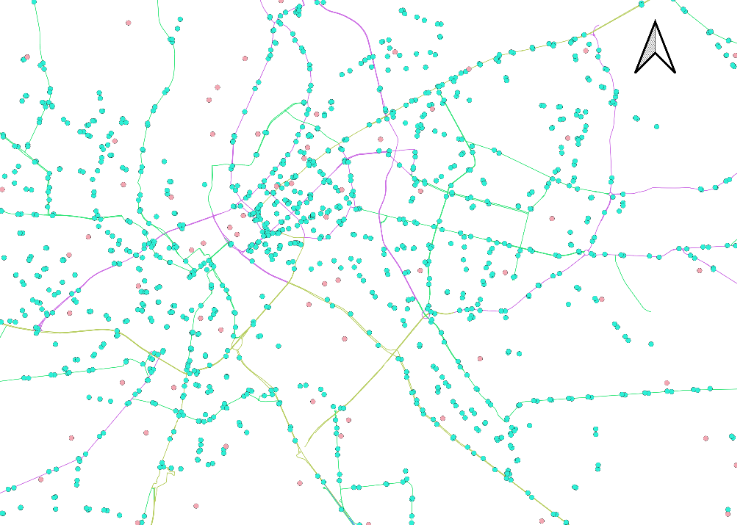
The transport network map shows the distribution of roads, railways, and public transport infrastructure across Riga. Major transportation corridors are concentrated in the central urban area.

Public Transport Accessibility

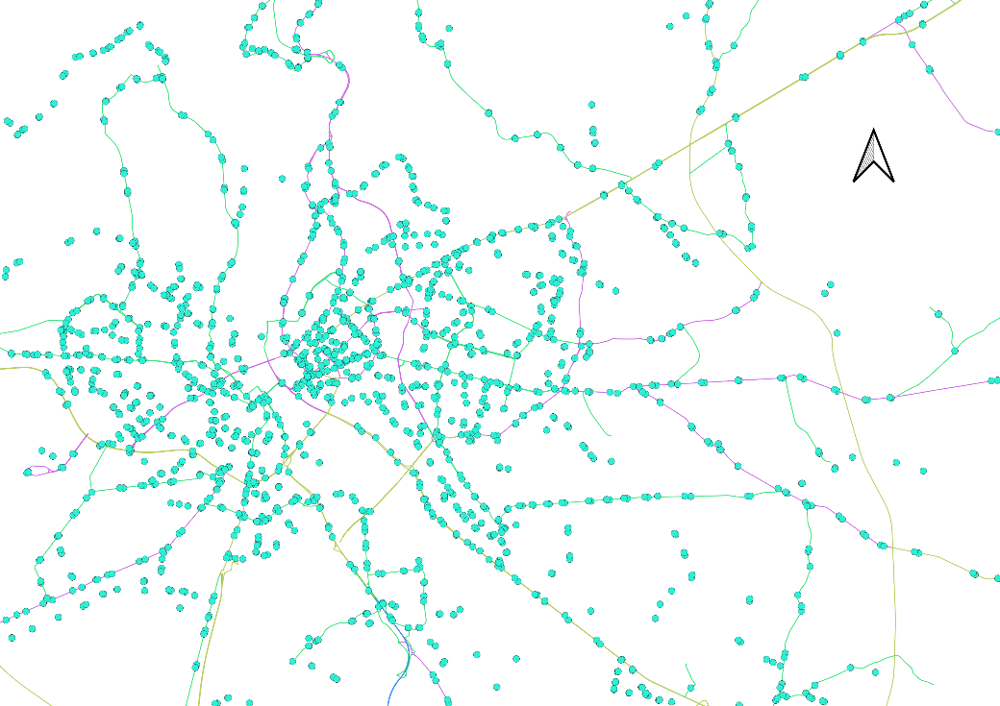
The accessibility analysis indicates that central areas of Riga are generally well served by public transport. The 500-meter buffer zones show that large portions of the urban area are located within walking distance of transport stops. Coverage decreases in peripheral areas.

5. Conclusion
This project demonstrates the application of GIS techniques for transportation analysis using publicly available OpenStreetMap data. QGIS was used to visualize transportation infrastructure and perform accessibility analysis through spatial buffering.
The project provided practical experience in data visualization, attribute classification, coordinate reference systems, and spatial analysis. Future improvements could include integrating GTFS timetable data, population density information, and network-based travel time analysis.

